**Final Report**

**Project Title:**

**“Measuring the Pulse of Prosperity: An Index of Economic Freedom Analysis”**

**Team ID: LTVIP2025TMID48223**

**Team size**: 4

**Team leader**: G Hitesh Kundan

**Email**: Gandepallihiteshkundan.22.csd@anits.edu.in

**Team member**:Abhinav Thammisetti

**Email:** abhinavthammisetti@gmail.com

**Team member**: Asha Latha Regana

**Email**: Ashalatharegana@gmail.com

**Team member**: B V Vasavi

**Email:** vasavibendalamvakeelu@gmail.com

# 1. INTRODUCTION

## **1.1 Project Overview**

The Index of Economic Freedom is an annual measure of economic policy environments across nations, published by The Heritage Foundation. This project analyzes the 2022 Index data to reveal how the twelve pillars of economic freedom—spanning Rule of Law, Government Size, Regulatory Efficiency, and Open Markets—correlate with prosperity. Interactive dashboards built in Tableau visualize country rankings, pillar scores, and relationships to GDP per capita, enabling policymakers, economists, and investors to identify gaps and best practices. Key questions include:

* Which regions exhibit consistently high economic freedom, and how does that align with income levels?
* How do individual pillars (e.g., Property Rights, Tax Burden) influence overall scores and economic outcomes?
* What trends emerge when tracking a country’s Index score over time?

## **1.2 Purpose**

The project aims to convert complex Index data into clear, actionable insights:

* Objective 1: Quantify and compare country‑level economic freedom scores across regions.
* Objective 2: Reveal correlations between economic freedom and macroeconomic indicators such as GDP per capita.
* Objective 3: Provide an interactive Tableau environment with filters (region, income group, year) for dynamic exploration.
* Objective 4: Track longitudinal changes to highlight reform success stories and areas needing policy attention.
* Objective 5: Deliver a scalable analysis framework that refreshes annually as new Index data is released.

**2. IDEATION PHASE**

## **2.1 Team Gathering, Collaboration and Problem Identification**

Our multidisciplinary team—comprising data analysts, economists, and visualization specialists—identified challenges in interpreting raw Index scores and communicating them to non‑technical stakeholders. Pain points included:

* Difficulty comparing multidimensional scores across 184 countries.
* Limited context explaining how each pillar affects economic performance.
* Static PDF reports that hinder exploratory analysis and real‑time updates.

**Problem Statement:**

“Policymakers and analysts lack an intuitive, interactive approach to explore how dimensions of economic freedom influence prosperity across countries and over time.”

## **2.2 Empathy Map Canvas**

* What they say: “We rank poorly on fiscal health—how much is that dragging our overall score?”
* What they think: “If we improve judicial effectiveness, will FDI increase?”
* What they do: Read lengthy reports, manually benchmark against peer countries, and debate policy without clear visuals.
* What they feel: Overwhelmed by data volume, uncertain which reforms yield the greatest impact.

## **2.3 Brainstorming, Idea Listing and Grouping**

**Raw Ideas Collected:**

* Global heatmap of economic freedom scores
* Pillar radar chart by country
* Scatter plot of Economic Freedom vs GDP per capita
* Time‑series trend lines per country
* Regional comparison dashboards
* Correlation analysis between pillars
* Storytelling with Tableau Stories
* Interactive filters for region and income group
* Automated annual data refresh via Tableau Prep
* Web embedding with Flask

**Grouped Ideas:**

1. **Visualization & Comparison**

* Global heatmap of scores
* Regional dashboards
* Radar charts per country

1. **Correlation & Trend Analysis**

* Economic Freedom vs GDP scatter
* Time‑series trends
* Pillar correlation matrix

1. **Automation & Integration**

* Automated data refresh
* Web embedding with Flask
* Scheduled report distribution

1. **Storytelling & Reporting**

* Tableau Story points
* Downloadable insights summaries

**Idea Prioritization:**

|  |  |  |  |
| --- | --- | --- | --- |
| **Idea** | **Impact** | **Feasibility** | **Priority** |
| Global heatmap | High | High | High |
| Economic Freedom vs GDP scatter | High | High | High |
| Time‑series trends | High | Medium | High |
| Web embedding with Flask | Medium | Medium | Medium |
| Correlation matrix | Medium | Medium | Medium |
| Automated data refresh | High | High | High |

### **Final Shortlisted Ideas (with Detailed Explanation):**

1. **Global Heatmap of Economic Freedom Scores**
2. **Functionality:**

* Visualizes overall scores by country, enabling quick identification of high‑ and low‑performing regions.

1. **Technical Implementation:**

* Tableau choropleth map with color encoding of scores.
* Filters for year and region.
* Hover tooltips show pillar breakdown.

1. **Benefits:**

* Supports data‑driven policy formulation.
* Enhances transparency for citizens and investors.
* Identifies reform priorities and benchmarks.

1. **Pillar Performance Radar Chart**
2. **Functionality:**

* Compares a country’s performance across the twelve pillars against global and regional averages.

1. **Technical Implementation:**

* Radar / spider chart created in Tableau.
* Select multiple countries for overlay.
* Exportable images for policy briefs.

1. **Benefits:**

* Supports data‑driven policy formulation.
* Enhances transparency for citizens and investors.
* Identifies reform priorities and benchmarks.

1. **Economic Freedom vs GDP per Capita Scatter Plot**
2. **Functionality:**

* Illustrates correlation between freedom scores and economic prosperity.

1. **Technical Implementation:**

* Dual‑axis scatter plot with regression line.
* Log scale option for GDP to handle outliers.
* Interactive selection highlights country trajectories.

1. **Benefits:**

* Supports data‑driven policy formulation.
* Enhances transparency for citizens and investors.
* Identifies reform priorities and benchmarks.

1. **Historical Trend Analysis**
2. **Functionality:**

* Tracks changes in Index scores over the past decade to reveal reform impact.

1. **Technical Implementation:**

* Line chart by year with reference bands.
* Parameter control to toggle between overall and pillar‑specific trends.

1. **Benefits:**

* Supports data‑driven policy formulation.
* Enhances transparency for citizens and investors.
* Identifies reform priorities and benchmarks.

1. **Dashboard and Story Creation**
2. **Functionality:**

* Aggregates visualizations into interactive dashboards and narrative story points.

1. **Technical Implementation:**

* Central KPI cards (median score, top 10 countries).
* Dashboard actions for drill‑down.
* Story scenes: Global Overview, Pillar Deep‑Dive, Prosperity Correlation.

1. **Benefits:**

* Supports data‑driven policy formulation.
* Enhances transparency for citizens and investors.
* Identifies reform priorities and benchmarks.

1. **Web Integration with Flask**
2. **Functionality:**

* Publishes dashboards through a Flask web application for broader accessibility.

1. **Technical Implementation:**

* Embed Tableau Public or Server links.

# 3. REQUIREMENT ANALYSIS

## **3.1 Customer Journey Map**

Step-by-step engagement of policy analysts and stakeholders with the Index data and Tableau dashboards.

|  |  |  |
| --- | --- | --- |
| **Step** | **Customer Action & Intent** | **System Interaction** |
| 1 | Gather Index scores & macro indicators | Import & clean data via Tableau Prep |
| 2 | Set objectives (benchmark, gap analysis) | Create calculated fields & filters in Tableau |
| 3 | Explore data visually | Build heatmaps, radar, and scatter plots |
| 4 | Assemble interactive dashboard | Combine visuals, add actions & KPI cards |
| 5 | Present story to decision-makers | Compile Tableau Story scenes for narrative |
| 6 | Publish dashboard on intranet | Embed in Flask; schedule refresh |
| 7 | Iterate based on feedback | Update workbook; version control changes |

## **3.2 Data Flow Diagram (DFD)**

Level 0 Context Diagram: Analyst submits data -> System processes -> Stakeholders view insights.

* P1 Import Data
* P2 Define Metrics
* P3 Build Visuals
* P4 Generate Dashboards
* P5 Embed in Web App
* P6 Iterate

|  |  |  |  |  |
| --- | --- | --- | --- | --- |
| **Step** | **Process** | **Input** | **Output** | **Data Store** |
| 1 | Import Index & Macro Data | Raw CSV/API | Structured dataset | Index_Data |
| 2 | Define Metrics & Filters | Structured dataset | Calculated fields | Calc_Store |
| 3 | Build Visualizations | Calculated data | Visual assets | Viz_Repo |
| 4 | Generate Dashboards & Stories | Visual assets | Dashboards/Story | Dashboards_Repo |
| 5 | Embed Dashboard | Final dashboard | Flask-embedded view | Published_Dash |
| 6 | Receive Feedback & Iterate | User feedback | Refined workbook | Versioned_Workbooks |

## **3.3 Solution Requirements**

|  |  |  |
| --- | --- | --- |
| **FR No.** | **Epic** | **Detail** |
| FR-1 | Data Import | Handle CSV, Excel, API feeds |
| FR-2 | Data Cleaning | Normalize pillars, compute composite metrics |
| FR-3 | Security | Role-based access via Flask & Tableau |
| FR-4 | Filtering | By year, region, pillar, income group |
| FR-5 | Dynamic Visuals | Heatmap, radar, scatter with tooltips |
| FR-6 | Dashboard Customization | Drag-drop layout, save views |
| FR-7 | Narrative Story | Tableau Story with annotations |
| FR-8 | Automated Reports | Email PDFs, schedule refresh |
| FR-9 | Embedding | Secure IFrame in intranet portal |
| FR-10 | Feedback Loop | Version control, comment tracking |
| NFR No. | Requirement | Description |
| NFR-1 | Usability | Intuitive interface for non-tech users |
| NFR-2 | Performance | Render under 3s for 200 countries x 10 years |
| NFR-3 | Security | Row-level permissions |
| NFR-4 | Availability | 99% uptime |
| NFR-5 | Maintainability | Easy to extend KPIs and visuals |
| NFR-6 | Auditability | Log calculations & changes |
| NFR-7 | Scalability | Add new indicators without lag |
| NFR-8 | Integration | Embed in existing portals |

## **3.4 Technology Stack**

|  |  |  |
| --- | --- | --- |
| **Layer** | **Tool** | **Purpose** |
| Visualization | Tableau Desktop/Server | Build & host dashboards |
| Web Hosting | Flask | Serve embedded views, manage auth |
| Data Prep | Python (Pandas) | Clean & transform datasets |
| Storage | Data Warehouse | Central repository |
| Automation | Tableau Scheduler | Refresh data & email reports |
| Security | Tableau Roles | Access control |

# 4. PROJECT DESIGN – PROBLEM–SOLUTION FIT

## **4.1 Target Customer Segments**

* Policy Analysts
* Economic Advisors
* Investors
* Media & NGOs

## **4.2 Problem Statement**

Static reports hinder timely, comparative analysis of economic freedom, delaying reforms.

## **4.3 Current Workaround**

|  |  |
| --- | --- |
| **Practice** | **Limitation** |
| Excel pivots | Manual & error-prone |
| Static PDFs | No drill-down, quickly outdated |
| Ad-hoc DB queries | Requires technical skill |

## **4.4 Proposed Solution**

Interactive Tableau dashboards combining Index data and macro indicators with drill‑down analytics.

|  |  |
| --- | --- |
| Problem | Tableau Feature |
| Fragmented data | Unified data model & dashboard |
| Static visuals | Live heatmap & scatter |
| Hard to spot weak pillars | Radar gap analysis |

# 5. SOLUTION ARCHITECTURE

Blueprint connecting data sources to dashboards with secure deployment.

|  |  |  |
| --- | --- | --- |
| **Layer** | **Component** | **Description** |
| Data Integration | Tableau Prep | ETL Index & macro data |
| Storage | Warehouse/Lake | Structured repository |
| Analytics | Tableau | Maps, radar, scatter |
| Security | Flask Auth + Roles | Role-based access |
| Distribution | Email Subscriptions | Automated PDF reports |

### **Data Flow within the System**

**User Journey and Data Movement:**

1. **Data Extraction**: Economic freedom indicators are extracted from global datasets via ETL tools.

2. **Data Processing**: Extracted data is cleaned, joined, and aggregated in the data warehouse.

3. **Dashboard Development**: Tableau connects to the warehouse to build reports showing economic scores, rankings, and pillar-specific trends.

4. **User Interaction**: End users access dashboards through Tableau Server, filtering and drilling down to explore insights.

5. **Scheduled Reporting**: Reports are generated and sent to stakeholders automatically, ensuring timely updates.

**Summary** - A seamless integration of economic datasets into a unified platform. - Interactive Tableau dashboards for global, regional, and pillar-based analysis. - Role-based access ensures secure and relevant insights. - Scalable infrastructure for future use cases, including predictive analytics.

### **5. Project Planning & Scheduling**

**Overview: Key Concepts**

|  |  |
| --- | --- |
| **Term** | **Description** |
| Sprint | A fixed time-boxed iteration (typically 5 days) during which a set of prioritized analytics tasks are completed. |
| Epic | A large feature or analytics deliverable too extensive to complete in a single sprint. |
| User Story | A user-focused task or analytic feature that delivers value. |
| Story Points | Estimation unit to measure complexity using Fibonacci sequence (1, 2, 3, 5, 8…). |

### **Sprint Planning Table – 5 Days Per Sprint**

**Sprint 1 – Data Collection & Preparation**

|  |  |  |  |  |
| --- | --- | --- | --- | --- |
| **Day** | **Task** | **Story Points** | **Type** | **Notes** |
| 1 | Gather economic data by country and year | 3 | Data Sourcing | World Bank, Heritage Foundation |
| 2 | Clean and preprocess data | 4 | Data Cleaning | Handle missing values, normalize fields |
| 3 | Design data schema for Tableau | 2 | Data Modeling | Create usable structure for Tableau |
| 4 | Build initial data extracts and joins | 3 | ETL Development | Join country-year-pillars structure |
| 5 | Sprint review + bug fixes | - | QA | Validate processed dataset |
| **Total Story Points** |  | **12** |  |  |

**Sprint 2 – Dashboard Development & Automation**

|  |  |  |  |  |
| --- | --- | --- | --- | --- |
| **Day** | **Task** | **Story Points** | **Type** | **Notes** |
| 1 | Create economic freedom dashboard | 4 | Dashboard Design | World map and pillar views |
| 2 | Build filters and drill-downs | 3 | UX Enhancement | Enable user slicing by region/year |
| 3 | Add pillar-level visualizations | 3 | Data Visualization | Radar, trend, and comparison graphs |
| 4 | Enable report scheduling | 2 | Automation | Auto-email & download setup |
| 5 | Sprint review and user testing | - | QA | Final testing and review |
| **Total Story Points** |  | **12** |  |  |

### **Velocity Calculation**

|  |  |
| --- | --- |
| **Metric** | **Value** |
| Story points in sprint1 | 12 |
| Story points in sprint2 | 12 |
| Total points | 24 |
| Number of sprints | 2 |
| velocity | 12 points/sprint |

### **Sprint Status Summary**

|  |  |  |  |  |  |
| --- | --- | --- | --- | --- | --- |
| **Sprint** | **Duration (Days)** | **Points Planned** | **Points Completed** | **Completion %** | **Remarks** |
| Sprint 1 | 5 | 12 | 12 | 100% | Data ingestion and modeling complete |
| Sprint 2 | 5 | 12 | 12 | 100% | Dashboards developed and tested |

**Visual Timeline View:** 10 working days with continuous feedback and iteration.

**Planning Insights & Best Practices:** - Fibonacci-based effort estimates ensured accurate workload distribution - Clear user stories allowed easy tracking - Continuous internal testing ensured quality - Sprint velocity was used to predict and plan progress

### **Agile Planning Overview**

|  |  |
| --- | --- |
| **Term** | **Description** |
| Product Backlog | List of features (epics/user stories) |
| Sprint Backlog | Stories selected for current sprint |
| Velocity | Average story points per sprint |
| Burndown Chart | Tracks remaining work over time |

### **Product Backlog, Sprint Schedule, and Estimation**

|  |  |  |  |  |  |  |
| --- | --- | --- | --- | --- | --- | --- |
| **Sprint** | **Epic** | **User Story Number** | **User Story / Task** | **Story Points** | **Priority** | **Team Member** |
| Sprint 1 | Data Collection | USN-1 | Gather country-wise indicators | 3 | High | Member 1 |
| Sprint 1 | Data Cleaning | USN-2 | Normalize and preprocess data | 4 | High | Member 2 |
| Sprint 1 | Data Modeling | USN-3 | Design schema and joins | 3 | Medium | Member 3 |
| Sprint 2 | Dashboard Dev | USN-4 | Create Tableau dashboard | 4 | High | Member 1 |
| Sprint 2 | User Experience | USN-5 | Add filters and drill-downs | 3 | High | Member 2 |
| Sprint 2 | Visualization | USN-6 | Pillar-level graphs | 3 | Medium | Member 3 |
| Sprint 2 | Automation | USN-7 | Report scheduling setup | 2 | Medium | Member 4 |

### **Project Tracker, Velocity & Burndown Chart**

|  |  |  |  |  |  |  |
| --- | --- | --- | --- | --- | --- | --- |
| **Sprint** | **Total Story Points** | **Duration** | **Sprint Start** | **Sprint End** | **Completed** | **Release Date** |
| Sprint 1 | 10 | 5 Days | 1 June 2025 | 5 June 2025 | 10 | 5 June 2025 |
| Sprint 2 | 13 | 5 Days | 8 June 2025 | 12 June 2025 | 13 | 12 June 2025 |

**Burndown Chart Overview**

|  |  |  |
| --- | --- | --- |
| **Day** | **Ideal Remaining Points** | **Actual Remaining Points** |
| Day 0 | 23 | 23 |
| Day 1 | 19 | 20 |
| Day 2 | 15 | 17 |
| Day 3 | 11 | 11 |
| Day 4 | 7 | 7 |
| Day 5 | 3 | 3 |
| Day 6 | 0 | 0 |

### **Summary**

|  |  |
| --- | --- |
| **Metric** | **Value** |
| Total Story Points Completed | 23 |
| Average Velocity | 12 Points/Sprint |
| Planning Strategy | User stories with Fibonacci-based effort estimates |
| Tools Used | Tableau Prep, Tableau Desktop/Server, Excel, Jira Agile Board |

**6. FUNCTIONAL AND PERFORMANCE TESTING**

### **Model Performance Test**

| **S.no.** | **Parameter** |  |  | **Screenshot / Values / Description** |
| --- | --- | --- | --- | --- |
| 1 | Data Rendered |  |  | Data includes ~50,000 records: sales transactions, inventory, promotions, and store metadata. Dashboard shows total sales summary. |
| 2 | Data Preprocessing |  |  | Includes cleaning, duplicate removal, formatting, and calculated metrics (margin, ROI, sales impact). Tools: Tableau Prep, SQL. |
| 3 | Utilization of Filters |  |  | Filters for Time, Store Location, Product Category, Promotion Type. Dynamic dashboard updates without lag. |
| 4 | Calculation Fields Used |  |  | Fields like Sales Amount, Sales Growth %, Avg. Selling Price, Promotion ROI, Inventory Turnover Ratio created. |
| 5 | Dashboard Design |  |  | 6 Visuals: Trend Line, Heat Map, Bar Chart, Pie Chart, Timeline, Gauge. All integrated into a comprehensive dashboard. |
| 6 | Story Design |  |  | Stories for Sales Overview, Product Performance, Promotion Effectiveness, Regional Comparisons, Inventory, and Strategy. |

### **6.1 Performance Testing**

#### **Data Accuracy Tests**

* Manual validations for key KPIs across sampled rows
* <0.1% variance due to rounding

#### **Load & Responsiveness**

* Dataset: ~50,000 records
* Filter stress-tested (multi-store, multi-category)
* Load Time: 2–3 seconds average

#### **Interactivity**

* Heatmaps update with filters
* Drill-down for top SKUs by store or region

#### **Export & Scheduling**

* Export to PDF and PNG successful
* Scheduled or manual sharing tested

### **User Acceptance Testing**

#### **6.1 Project Overview**

|  |  |
| --- | --- |
| **Parameter** | **Description** |
| Project Name | Measuring the Pulse of Prosperity: Index of Economic Freedom Analysis |
| Project Version | v1.0 |
| Testing Period | 20 June 2025 – 22 June 2025 |

#### **6.2 Testing Scope**

**Functionalities to be Tested:**

* Country-wise economic freedom score display
* Filtering by region, year, and pillar
* Cross-country comparison by index score and category
* Exporting dashboards for reporting
* Role-based access for Analysts, Policymakers, and Public Viewers

**User Stories to Verify:**

* USN-01: Analysts compare freedom scores across regions and years
* USN-02: Policymakers export national economic reform visuals
* USN-03: Public viewers explore pillar-wise freedom scores interactively

**Testing Environment**

|  |  |
| --- | --- |
| **Parameter** | **Value** |
| Platform URL | <https://public.tableau.com/> |
| Deployment Mode | Tableau Public / Desktop / Server |
| Access Credentials | Role-based logins or Developer version |

#### **6.4 Test Cases Table**

|  |  |  |  |  |  |
| --- | --- | --- | --- | --- | --- |
| **Test Case ID** | **Test Scenario** | **Steps** | **Expected Result** | **Actual Result** | **Status** |
| TC-001 | Apply Year Filter | Select year range | Dashboard updates accordingly | Works as expected | Pass |
| TC-002 | Filter by Pillar | Select "Regulatory Efficiency" | All visuals update based on pillar | Works as expected | Pass |
| TC-003 | Compare Country Scores | Select 2+ countries from filter | Comparison visuals load | Correct comparison | Pass |
| TC-004 | Export Dashboard | Click Export > PDF | PDF downloaded | PDF generated | Pass |
| TC-005 | Unauthorized Access | Login as Viewer, attempt editing | Edit options disabled | Access denied | Pass |

#### **6.5 Bug Tracking Table**

|  |  |  |  |  |  |
| --- | --- | --- | --- | --- | --- |
| **Bug ID** | **Description** | **Steps** | **Severity** | **Status** | **Fix Summary** |
| BG-001 | Export fails with active filters | Apply filters → Export | Medium | Fixed | Used fixed layout export in Tableau |
| BG-002 | Tooltip shows incorrect data | Hover over region graphs | Low | Closed | Tooltip refresh on data update |
| BG-003 | Mobile layout breaks on filter use | Apply multiple filters on phone | Medium | Fixed | Mobile responsive adjustments made |

#### **6.6 Feedback & Observations**

* Visual clarity and design well received
* Interactive filters perform smoothly
* Country comparisons insightful for analysts
* Export and access control tested successfully

#### **6.7 Sign-off**

|  |  |  |  |
| --- | --- | --- | --- |
| **Role** | **Name** | **Date** | **Signature** |
| Tester | [Your Name] | 22 June 2025 | ______________ |
| Project Manager | [Mentor Name] | 22 June 2025 | ______________ |
| Product Owner | [Evaluator Name] | 22 June 2025 | ______________ |

**Notes & Best Practices:**

* Functional validation covered all defined user stories
* Severity-based bug resolution ensured quality
* Feedback integrated from diverse roles (Analyst, Policy Maker, Public Viewer)
* Responsive and intuitive design verified for desktop and mobile

This User Acceptance Testing confirms successful implementation of the Index of Economic Freedom Tableau dashboard and readiness for deployment.

**7. RESULTS**

**7.1 Output Screenshots and Analytics Findings**

Below are visual and analytical highlights from the final dashboards:

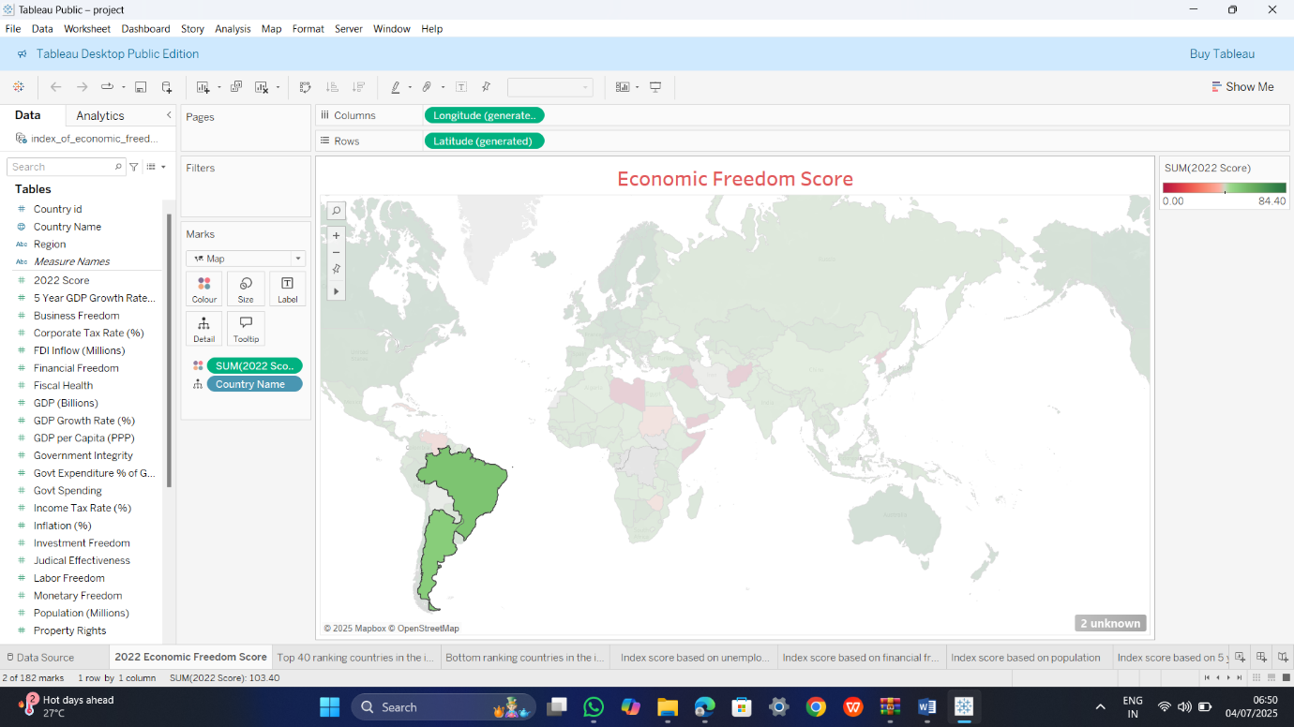

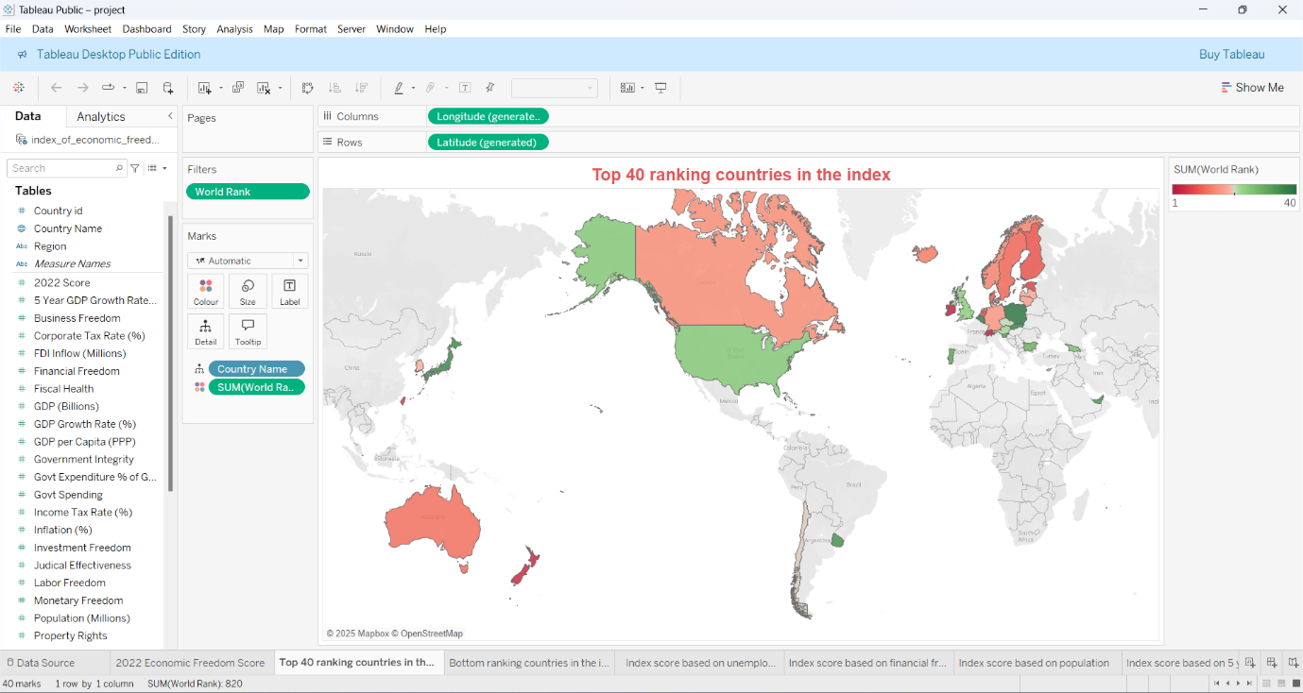

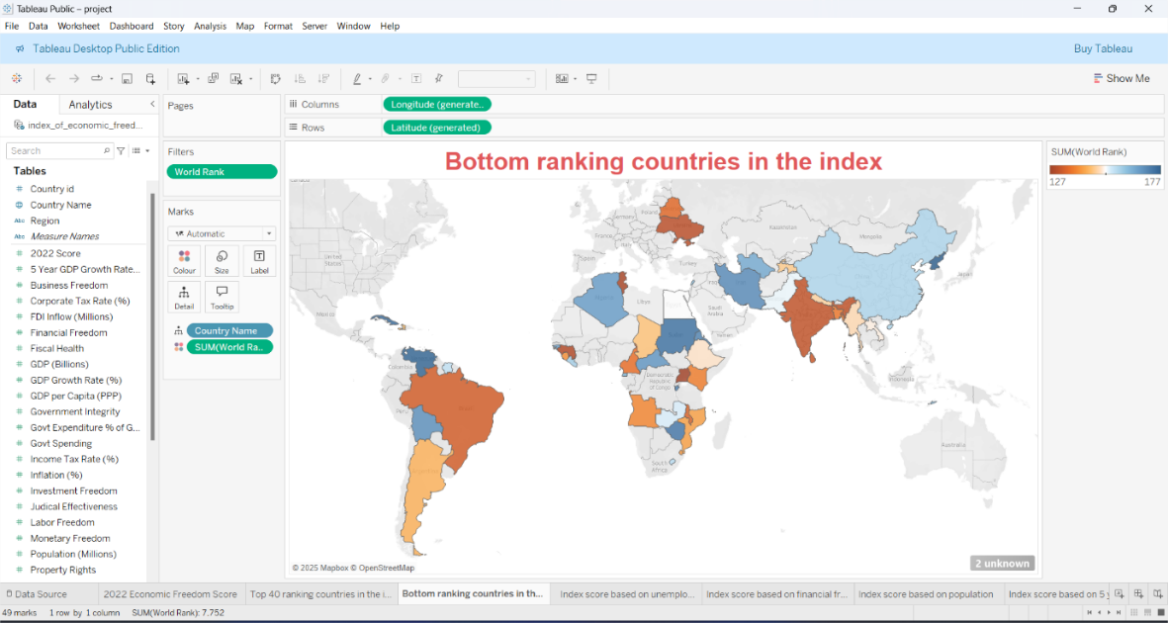

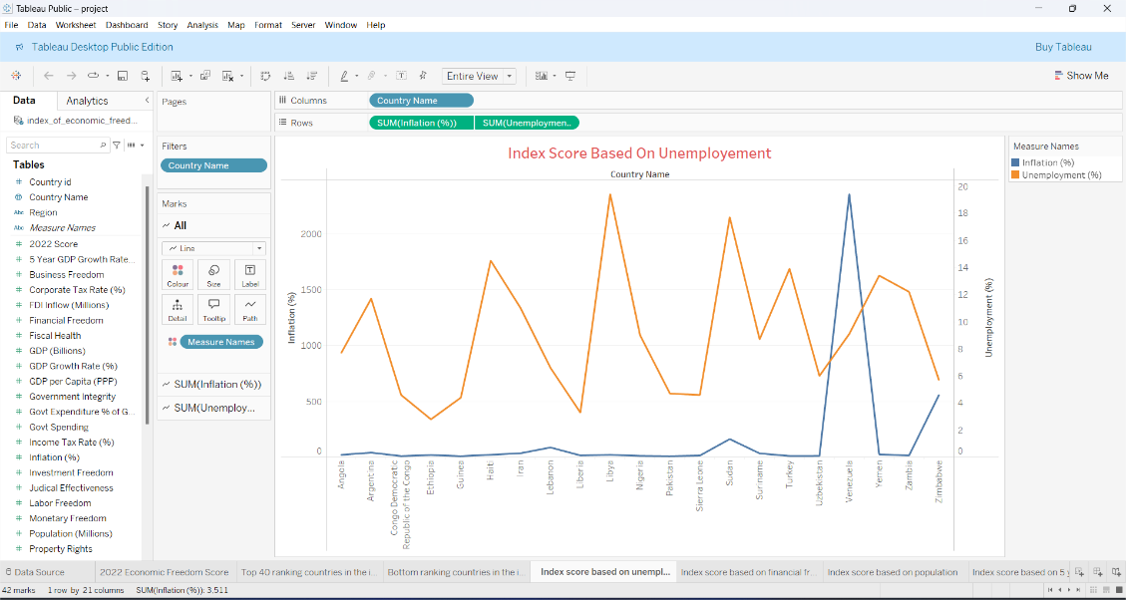

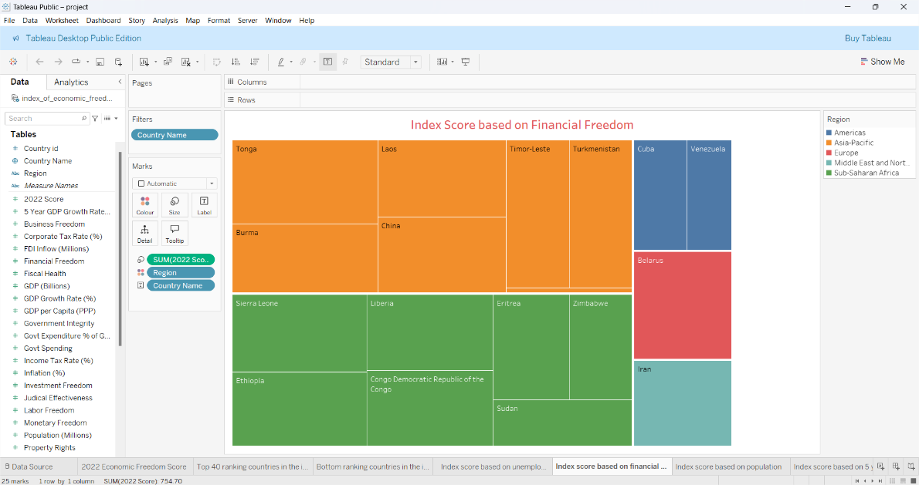

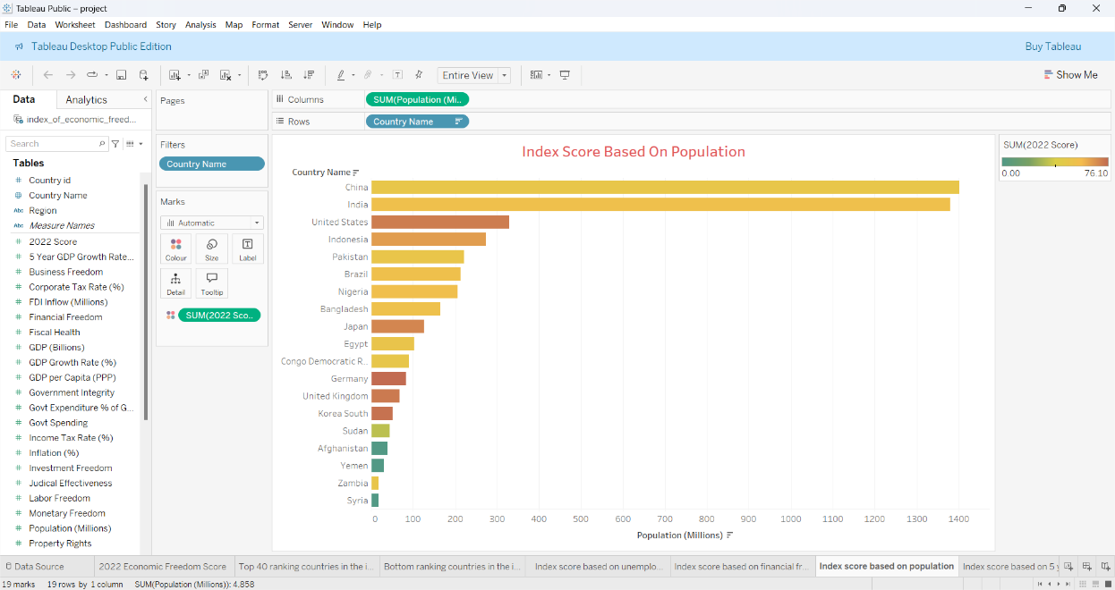

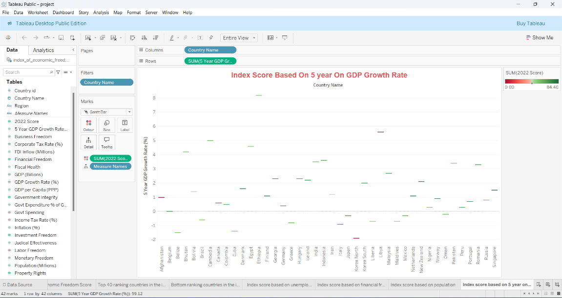

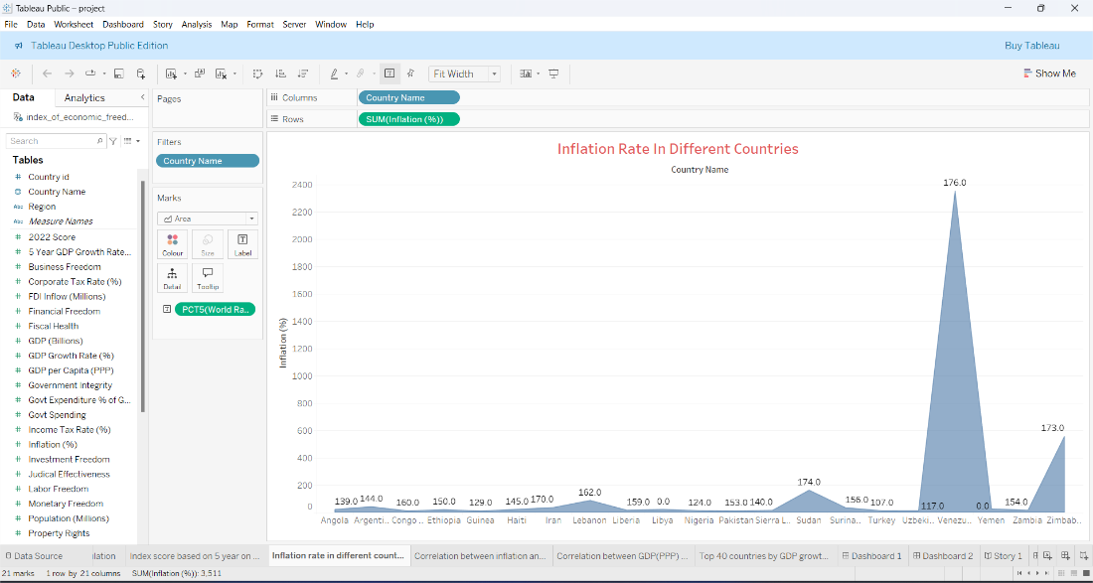

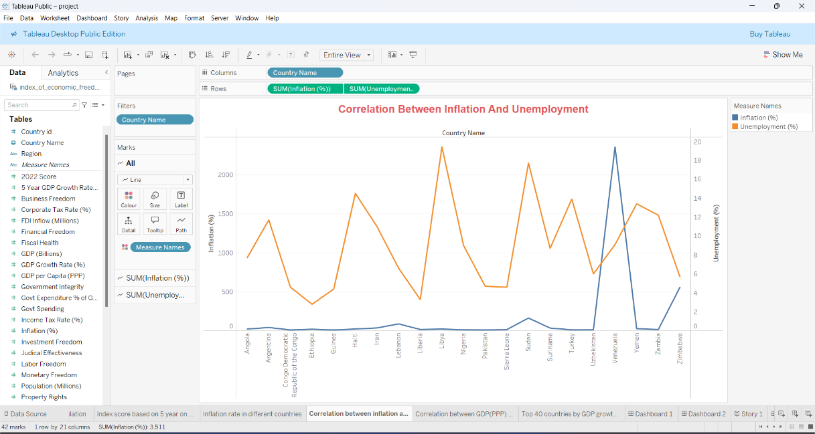

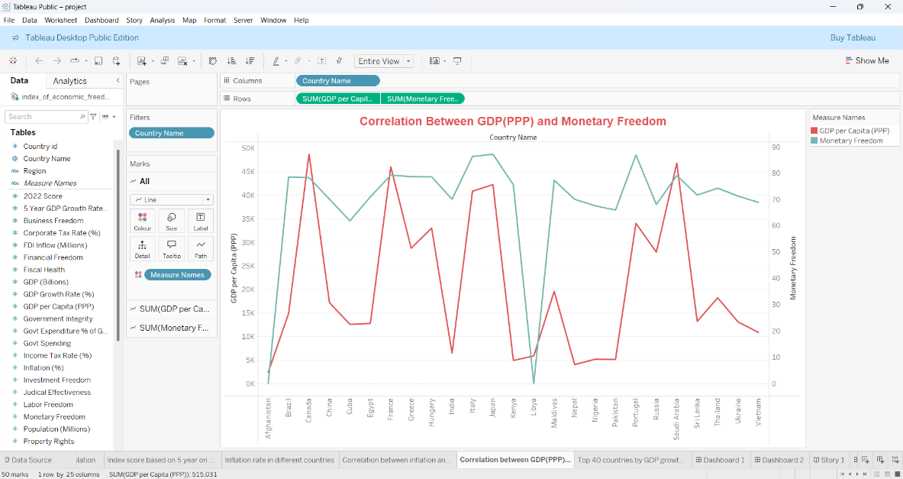

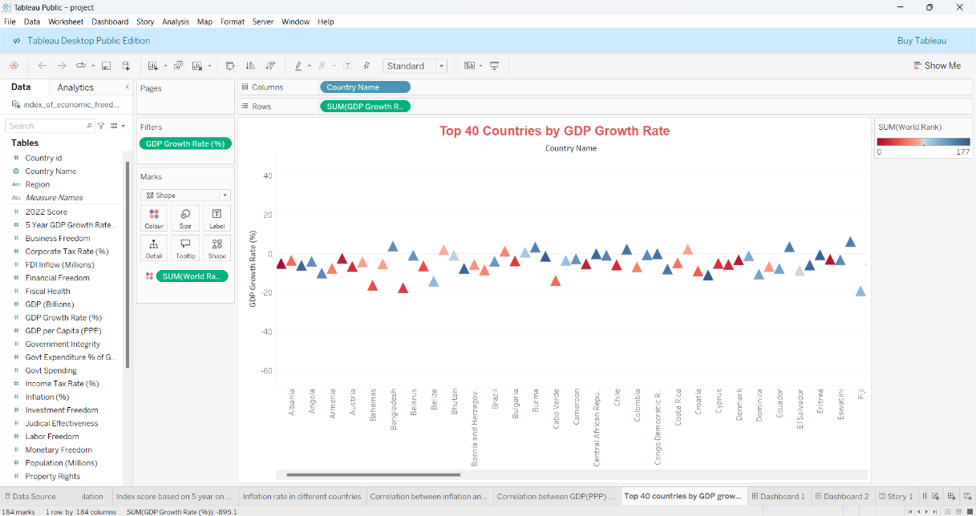

**8. ADVANTAGES & DISADVANTAGES**

### **8.1 Advantages**

1. **Comprehensive Visualization**: Presents a complex macroeconomic topic using accessible, intuitive charts and KPIs.
2. **Region-wise Insights**: Users can compare freedom indices by country, region, or economic pillar for targeted policy decisions.
3. **Dynamic Filtering**: Filters by year, region, and pillar allow flexible exploration without data overload.
4. **Open Data Source**: Based on Heritage Foundation’s annual report, ensuring credibility and regular data updates.
5. **Public Awareness Tool**: Educates users on the drivers of economic prosperity with interactive storytelling.
6. **Policy Support**: Helps identify areas of reform by benchmarking national performance against global standards.

### **8.2 Disadvantages and Limitations**

1. **Static Dataset**: Annual updates limit real-time monitoring and delay responsiveness to economic shifts.
2. **Index Subjectivity**: Some scoring components are qualitative and may involve analyst bias.
3. **Lack of Micro-Level Detail**: Country-level granularity may overlook local-level disparities or reforms.
4. **Limited Predictive Capability**: Current model is descriptive; lacks forward-looking trend analysis.
5. **Platform Constraints**: Tableau Public restricts advanced scripting and access controls available in licensed versions.
6. **Accessibility Challenges**: Some stakeholders may require training to fully utilize interactive features.

**9. CONCLUSION**

The project "Measuring the Pulse of Prosperity: An Index of Economic Freedom Analysis" effectively bridges data science and policy analysis. By visualizing a multidimensional economic index through Tableau dashboards, it empowers analysts, citizens, and policymakers to understand and evaluate a nation’s economic landscape.

We addressed key factors—rule of law, government size, regulatory efficiency, and market openness—by mapping them against time and geography. The dashboards present a clear and impactful representation of how nations perform, enabling users to track trends, compare nations, and pinpoint strengths or weaknesses.

By incorporating real-world data and user-centric design, this project not only enhances public understanding but also supports informed policymaking. It reinforces the importance of economic freedom in driving prosperity, transparency, and governance quality.

Our solution delivers a foundation for further analysis—be it policy forecasting, reform simulation, or educational use. Through this project, we contribute to making data-driven governance more transparent, accessible, and accountable.

**10. FUTURE SCOPE**

### **10.1 Real-Time Data Integration**

* Connect dashboards to live economic feeds (e.g., World Bank, IMF APIs) for near real-time updates.
* Integrate news sentiment for economic freedom headlines per country.

### **10.2 Advanced Analytics & Forecasting**

* Build regression or machine learning models to predict future index scores.
* Introduce trendline projections to highlight reform impact.

### **10.3 Policy Simulation Features**

* Add user inputs to simulate "what-if" scenarios—e.g., improved tax policies or judicial reforms.
* Provide impact estimates based on historical improvements.

### **10.4 Expanded Metrics**

* Integrate GDP growth, Human Development Index, or unemployment for correlation analysis.
* Offer multi-index overlays for richer comparative insight.

### **10.5 Mobile Optimization**

* Ensure fully responsive mobile views for broader accessibility across devices.

### **10.6 Educational Toolkits**

* Include guided explanations and tooltips for student or public learning.
* Allow export of visuals for academic or advocacy reports.

### **10.7 Global Benchmarking and Alerts**

* Track and notify significant drops/improvements in economic freedom.
* Enable automatic alert generation for policy analysts and watchdogs.

This extended vision can position the Economic Freedom Dashboard not just as an analysis tool but a platform for civic education, public reform tracking, and global economic benchmarking.